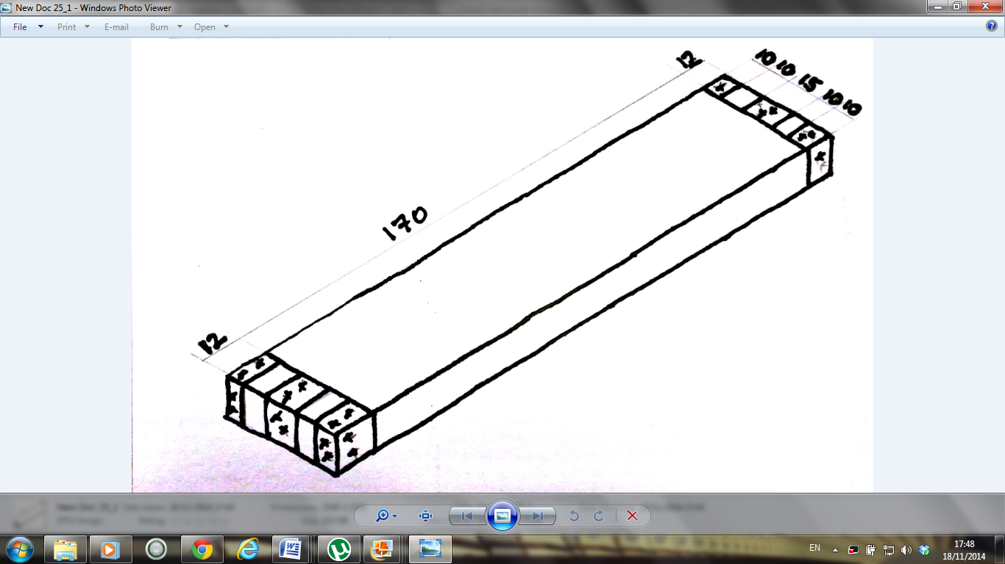

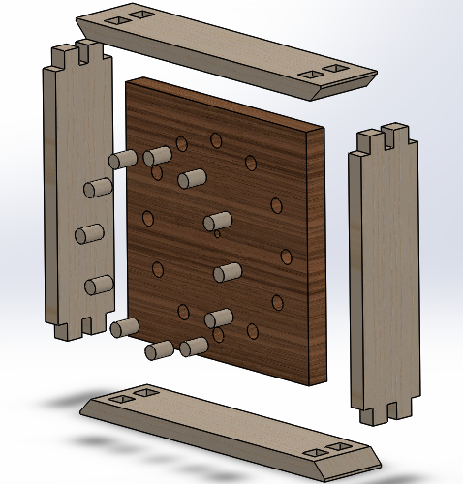

Sides of the Clock  
2 Parts are needed

5th Year & LCA Clock

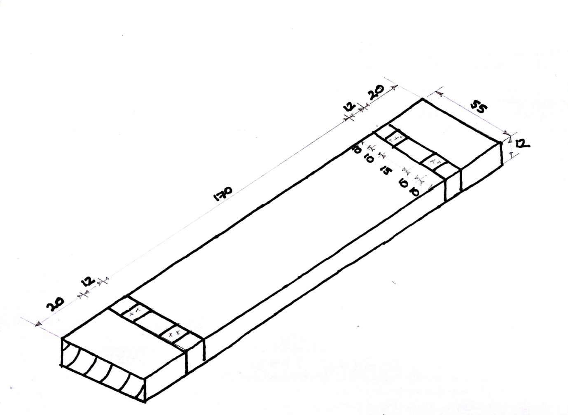



Top and Bottom of Clock  
2 Parts are needed

5th Year & LCA Clock