Heat Terms
Thermal Conductivity
This is a measure of the rate of heat flow through a material. The benefit of this measure is that it allows various insulating materials to be easily compared. It is measured in W/mK (Watt/metre Kelvin).
Thermal Resistivity
Resistivity is the rate at which heat does not flow through a material. This is the reciprocal or opposite of conductivity. It is measured in mk/w (meters Kelvin per Watt)
Thermal Resistance (R-value) — It’s a measure of a material’s ability to resist the flow of heat energy through a particular thickness of a material. Measured in m²K/W.
Thermal Transmittance (U-value)— This is a measure of the rate at which heat passes through a particular element of a building (e.g. a cavity wall). It is measured in W/m2K. The U-value takes into account the resistances of the various materials, the surface resistances and the cavity (if present).

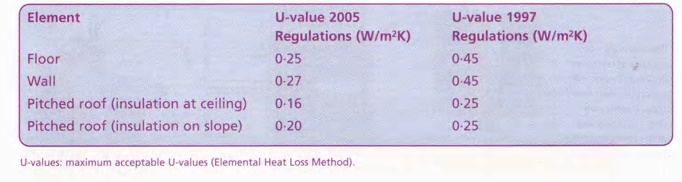
Heat Transfer
Heat is transferred via the mechanisms of conduction, convection, radiation and evaporation.
Conduction is the transfer of heat energy through a substance without any movement of the substance. For example, when a concrete cavity-walled house is heated, the inner leaf of the wall is heated. The heat energy is conducted through the blockwork until it reaches the insulation.
Convection is the transfer of heat of the substance. Water is moved heated water becomes less dense For example, when an immersion energy through a substance by movement upwards by convection when heated (the and rises, the cool water falls with gravity). heater is used, the heated water in the storage tank rises. This is why the hot water distribution pipe is connected to the top of the cylinder.
Radiation is the transfer of heat energy from one point to another in the form of electromagnetic waves. An example of this is when sunlight shines through a window and heats a room (solar heat gain).
Evaporation is the process by which liquid water is converted into a gaseous state. The human body cools by evaporation — evaporation requires a lot of heat energy (the evaporation of one gram of water at a temperature of 1000 Celsius requires 540 calories of heat energy) and so has a cooling effect on the body. Evaporation occurs whenever a damp object is heated. For example, rainwater can sometimes be seen evaporating from the tiles on a roof when the sun shines after a rain shower, or every time a kettle is boiled water evaporates and can be seen as steam.
Building for Energy Conservation
Houses will need to become more energy efficient if the environmental impact of space and water heating in houses is to be reduced. Heat is lost from houses through various routes, as shown below.
The building regulations provide strict guidance in relation to the construction of houses to reduce energy consumption (Building Regulations2005, Technical Guidance Document L: Conservation of Fuel and Energy — Dwellings).
The regulations aim to ensure the conservation of energy by:
• limiting the heat loss and maximising the heat gains through the fabric of the building,
• controlling the output of the space heating and water heating systems,
• limiting the heat loss from pipes, ducts and vessels used for the transport or storage of heated water or air.
Energy Performance of Buildings (BER) Building Energy Rating
In 2002, the European Union issued the Energy Performance of Buildings Directive (EPBD). It contains a range of provisions aimed at improving energy performance in newly built and existing buildings. The Directive requires anyone who is offering a property for sale or rent to provide prospective clients with detailed information and advice about the energy performance of the property . The intention is that this information and advice will help consumers to make informed decisions leading to practical actions to improve energy performance.
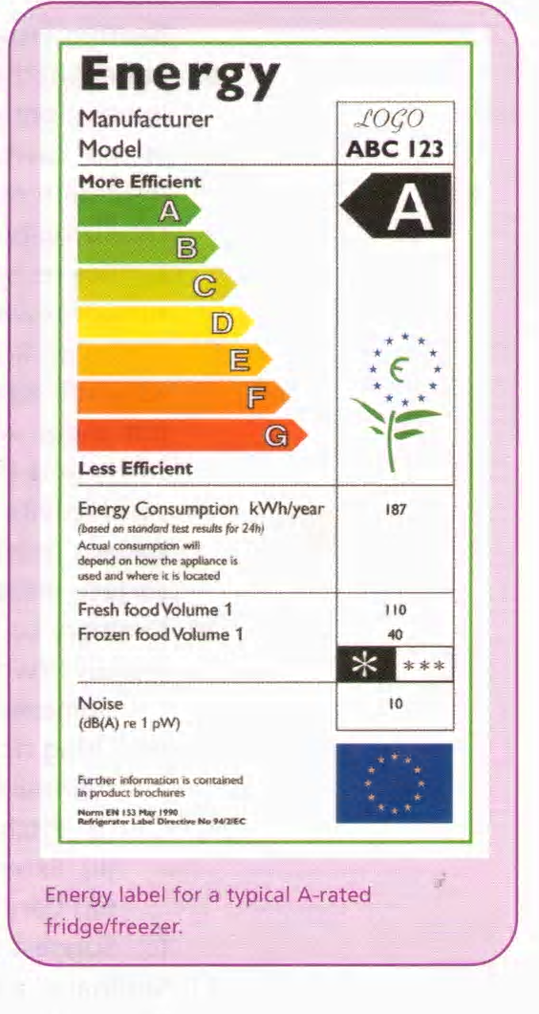
The most interesting part of the directive is the requirement for Building Energy Rating certificates (effectively an energy label) to be available at the point of sale or rental of a building, or on completion of a new building. The energy rating certificate must be accompanied by a report setting out recommendations for cost-effective improvements to the energy performance of the building. In Ireland, this is expected to impact on over 150,000 sale or rental transactions per year in the residential market. The directive also specifies targets for measures to improve the efficiency of boilers and heating installations.
The directive must be brought into operation by EU Member States by 4 January 2006. However, because of a possible shortage of independent experts to carry out certifications, full implementation is not required until 2009.
Energy rating is a tried and tested concept in Europe and Ireland. The energy rating label system introduced for laundry, dishwashing and refrigeration appliances in 1996 led to a thirty per cent increase in the efficiency of fridges and freezers by 2000. This meant that over half of all cold appliances for sale in Ireland were in the class A by 2000.
Energy performance certificates will have to be displayed in large buildings (over 1,000 m2) regularly visited by the public, to raise awareness among the general public about the issue of energy efficiency in their local community.
Interstitial Condensation
Condensation occurs when warm moisture-laden air – generally found in kitchens or bathrooms –comes into contact with cold surfaces at, or below, the dew point of the air. “Dew point” refers to the temperature at which saturated air condenses. Condensation that occurs in the wall or partition is known as interstitial condensation.
Water vapour present on the insulation reduces its effectiveness by conducting heat out of the building faster than if the insulation were dry. Damp moist air inside the timber partition generates mould and fungal growth as well as causing wet rot.
Interstitial condensation may be prevented by placing a sheet of 500 gauge polythene on the inner surface of the partition next to the plaster board – on the warm side of the insulation. Alternatively, foil backed plasterboards may be used. Both methods prevent the passage of warm, saturated air from passing into the partition wall and therefore eliminate any possibility of interstitial condensation occurring.
Methods of Improving Insulation

