Heat

Q1 State the recommended temperatures for the following rooms?

Living Room  
Office  
Factory

Ans   
Living Room 20 -21 °C  
Office 18 -19 °C  
Factory 16-17 °C

Q2 Give 4 sources of heat gain in a house.

People  
Lighting  
Solar Radiation  
Electrical Appliances  
Cooking

Q3 Explain the term “solar heat gain”?

Solar heat gain (also known as solar heat or passive solar gain) refers to the increase in temperature in a space, object or structure that results from [solar radiation](http://en.wikipedia.org/wiki/Solar_energy).

Q4 List 3 factors that influence solar heat gain in a building?

* Latitude

The latitude of the buildings location.The further away from the equator that a location resides, the less sunlight that this location receives.

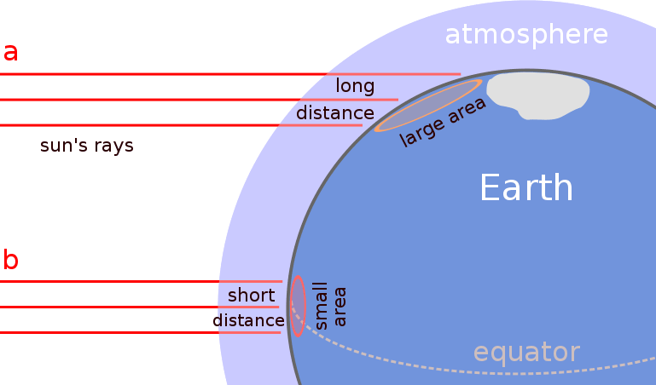

* 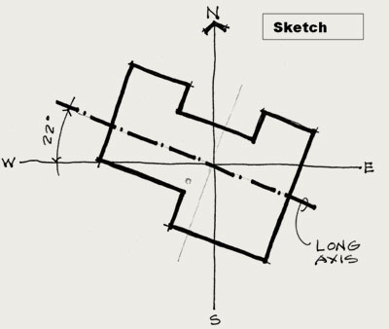Building Orientation  
  Orientation is the positioning of a building in relation to seasonal variations in the sun’s path as well as prevailing wind patterns. Good orientation can increase the energy efficiency of your home, making it more comfortable to live in and cheaper to run.
* Seasons  
  There is a greater amount of solar heat gain light from the sun during summer months compared to winter months, this can be seen when we plot a sun path diagram as shown below.

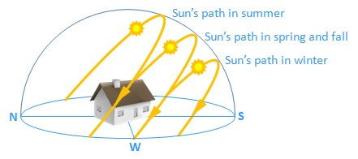

Q5 Write a short note on 3 methods of heat transfer?

**Conduction** is the transfer of heat energy through a substance without any movement of the substance. For example, when a concrete cavity-walled house is heated, the inner leaf of the wall is heated. The heat energy is conducted through the blockwork until it reaches the insulation.

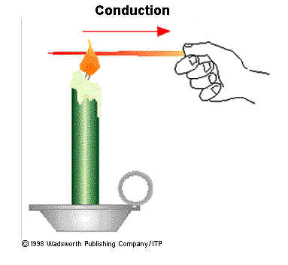

**Convection** is the transfer of heat in a liquid or a gas by the movement of particles. An example of this is a hot water cylinder or a kettle. When heated the water rises to the top of the cylinder.

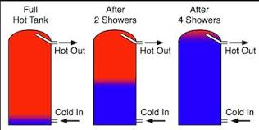

**Radiation** is the transfer of heat energy from one point to another in the form of electromagnetic waves. An example of this is when sunlight shines an heats a solar panel (solar heat gain).

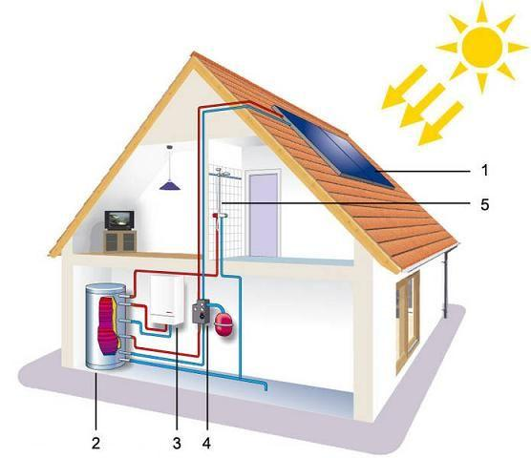

Q 6 Indicate using a line-diagram the percentage of heat loss from a building with no insulation.

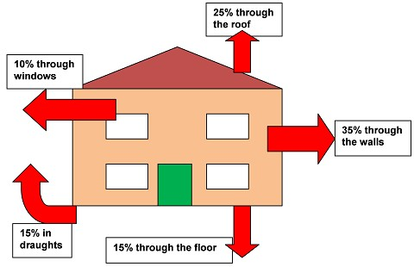

Q7 What is a thermal insulator?

A **thermal insulator** is something that prevents **heat** from moving from one place to another. There are 3 main ways that **heat** can travel: convection, conduction, and radiation.

Q8 What is a thermal conductor?

A **thermal conductor** is a material that allows energy in the form of **heat**, to be transferred within the material, without any movement of the material itself.

Q9 Explain the following terms and give an appropriate symbol and unit for each.

Thermal Conductivity (k Value)  
The rate at which heat passes through a specified material.   
Symbol of Thermal Conductivity is k-Value.  
The unit of measurement for Thermal Conductivity is W/m °C  
Thermal Resistivity (r Value)  
Resistivity is the rate at which heat does not flow through a material. This is the reciprocal or opposite of conductivity.  
Symbol of Thermal Resistivity is r-Value  
The unit of measurement for Thermal Resistivity is m °C/W

Thermal Resistance (R Value)  
It’s a measure of a material’s ability to resist the flow of heat energy through a particular thickness of a material. The thermal resistance can only be obtained by knowing the thickness of the building element in metres and either the r or k value of the element. The building element could be insulation, glass, blocks, plaster etc.

R = t ÷ k or R = r x t

Symbol of Thermal Resistance is R-Value

The unit of measurement for Thermal Resistance is in m2 °C/W  
  
Thermal Transmittance

This is a measure of the rate at which heat passes through a particular element of a building (e.g. a cavity wall). The U-value takes into account the resistances of the various materials, the surface resistances and the cavity (if present).

U-value = 1 ÷ Resistances added together

Symbol of Thermal Transmittance is U-Value

The unit of measurement for Thermal Transmittance is W/ m2 °C

Q10 Outline using notes and freehand sketches how thermal performance of a building can be improved.

Ans

The thermal performance can be improved by using the following methods:

1. Fitting external insulation to the exterior of the building.

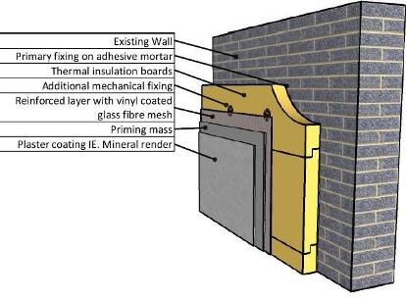

1. Pumping insulation into the wall cavity.

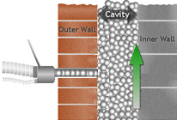

1. Fixing insulation to the interior walls of the house.

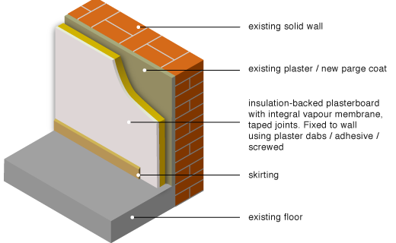

**To Calculate U-Value Question**

R = T÷k

R = r x T

U = 1÷RT

R = RESISTANCE

T = THICKNESS

k = CONDUCTIVITY  
r = RESITIVITY

RT = TOTAL RESISTANCE

U = U - VALUE

**Cost of Heat Loss Annually  
(Needed For Part B)**

Step 1 . Heat Loss in KJ = U value x Area x Temp Difference ÷ 1000

Step 2. Time 1 Litre of oil will last = (Calorific Value of Oil ÷ Heat Loss) ÷ 3600

Step 3. Amount of oil used = Heating Period (Hours x Days x Weeks) ÷ Time 1 Litre will last for

Step 4. Cost of Oil = Amount of oil used x price of oil per litre

**Daily Savings between 2 items**

1. Overall heat Loss of Item No 1 = U value x Area x Temp Difference ÷1000

1. Overall heat Loss of Item No 2 = U value x Area x Temp Difference ÷1000

2. Daily Heat Loss of Item No 1 in kj= Overall heat Loss of Item No 1 x No of Seconds in a day

2. Daily Heat Loss of Item No 2 in kj = Overall heat Loss of Item No 2 x No of Seconds in a day

3. Difference between Daily Heat Losses =Daily Heat Loss of Item No 1 - Daily Heat Loss of Item No 2

4. Reduction in Oil Per day in litres = Difference between Daily Heat Losses ÷ Calorific Value of Oil

5. Daily Savings = Price of Oil per Litre X Reduction in Oil Per day in litres

**To find the thickness of insulation given a new U Value.**

Required Resistance - Existing Resistance = Resistance that the insulation must give.

Thickness = R x K or Thickness = R ÷ r

**Overall Heat Loss**

Heat Loss in Watts = U value x Area x Temp Difference